Source Tree User Manual

|  |
| --- |
| This document contains confidential and proprietary information of Aimco; such information is and shall remain the property of Aimco. It is furnished for evaluation purposes only. Except with the express prior written permission of Aimco, neither this document nor any of the information contained herein may not be published, disclosed, or used for any other purpose. |

Authors

| Name | Location | Phone | Email |
| --- | --- | --- | --- |
| Pinaki Ghosh | Kolkata |  | pinaki.ghosh@aimco.com |
|  |  |  |  |
|  |  |  |  |

Revision History

| Date | Author | Description |
| --- | --- | --- |
|  |  |  |
|  |  |  |
|  |  |  |
|  |  |  |
|  |  |  |
|  |  |  |

Open Points

| Sl No | Point |
| --- | --- |
|  |  |
|  |  |
|  |  |

# **Definition:**

Source Tree is a GIT Client that provides seamless UI integration with GIT repositories, a robust workflow that helps to manage releases in a systematic way.

# **Required Softwares:**

* GIT
* Source Tree 1.5.2
* Mercurial

# **Basic Functions:**

The following section provides details and steps about basic functions that can be done in Source Tree:

# **Cloning a repo**

Cloning a repository means downloading the code from the remote server. It downloads the entire remote i.e., Origin (head, master and all branches present in remote server) which is visible under Remote section of the source tree and downloads the origin\master into local\master which is visible under Branches section of the source tree. The branches of the remote don’t come to local repository on cloning.

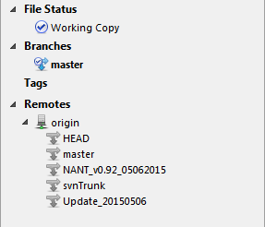

# **Branch creation from local repository (local master or local branch)**

To create a branch from one of the branches of the local repository, check out the branch by right clicking on it then click the branch option from the top menu.

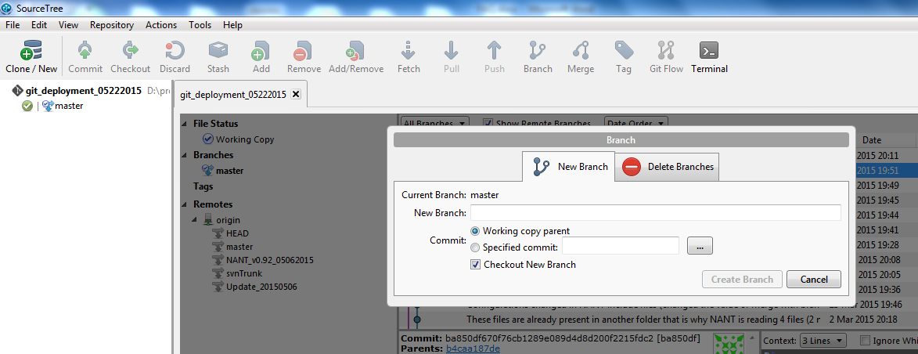

# **Branch creation from remote branch**

Double click on the branch (visible under Remote section of the source tree) to create a new branch. The new branch will be visible under the branches section of the source tree.

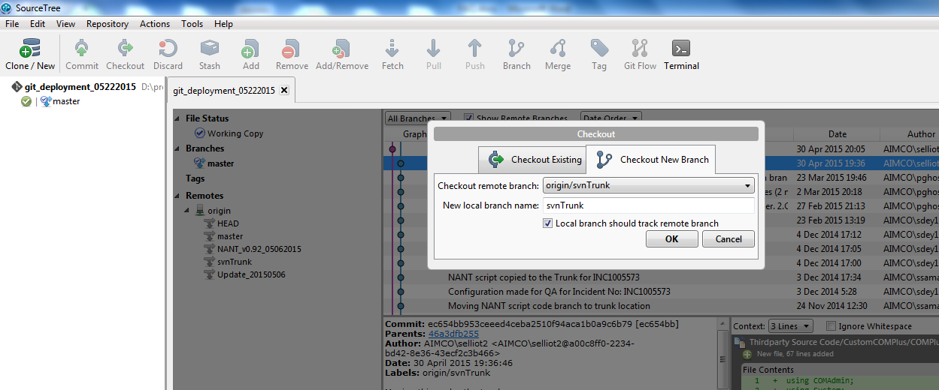

# **Track Local Branch with the remote branch**

Right click on the branch seen under the Branches section of the source tree and select the option as shown below:

Local branch can be tracked with the remote branch only.

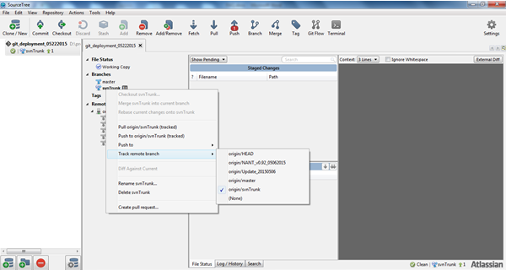

The screenshot below shows that the svnTrunk branch in the local repository is 1 commit ahead to that of the svnTrunk branch in remote.

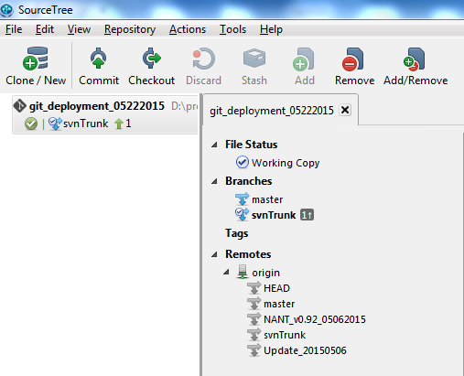.

# **Stage**

Changes done in any file needs to be staged before committing to the branch. Files can also be staged during the time of committing the files. Stage is also known as Index.

Screenshot 1 (before staging)

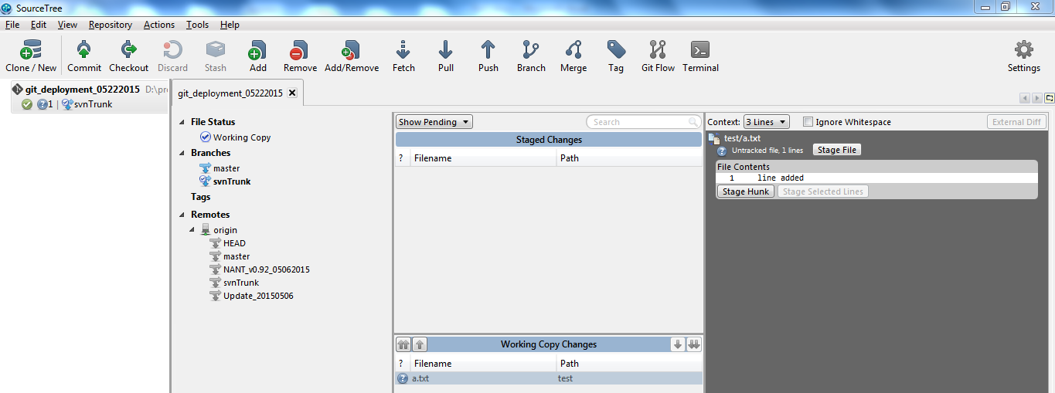

Screenshot 2 (after staging)

Drag the file from the ***Working Copy Changes*** section to ***Staged Changes section*** of the source tree. All the staged files are seen in the Staged Changes section.

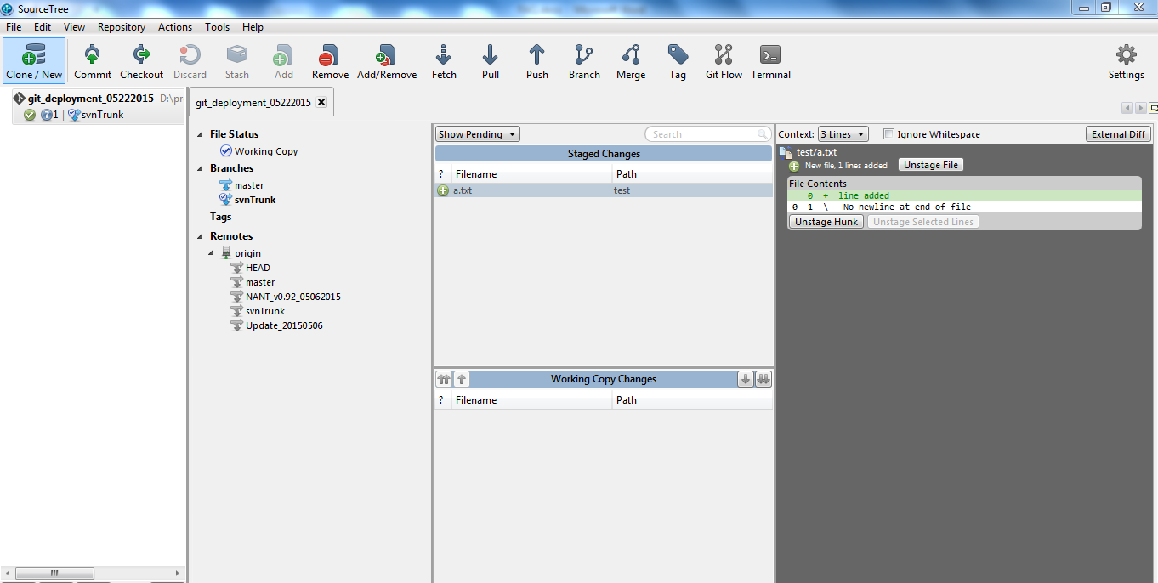

Stage File

It stages the entire file from the ***Working Copy Changes section*** *to* ***Staged Changes section*** of the source tree.

Unstage File

It un-stages the entire file from the ***Staged Changes section*** *to* ***Working Copy Changes section*** of the source tree.

# **Hunk**

Hunk in source tree means differences. For an example If 1 new line is added each time after line numbers 3,9 & 14 then there would be 3 hunks in the file whereas if 3 new lines are added after line no: 9 then in this case there is 1 hunk made in the file.

Stage Hunk

If multiple sections of the file are changed then the ***Stage Hunk*** feature should be used by selecting a particular section of the file. The file will be staged from the ***Working Copy Changes section*** to the ***Staged Changes section*** of the source tree.

Stage selected lines

Select a line/(s) from the right pane after selecting the file from the ***Working Copy Changes section***. The selected lines will be staged and the file with only the selected line will be visible under the ***Staged Changes section*** of the source tree.

Discard selected lines.

Select the file from the ***Working Copy Changes*** section. Select the line to discard. On selecting the Discard selected lines feature it deletes the line from the local repository also.

Discard Hunk

It will discard the selected section (hunk) of the file.

Unstage Hunk

It un-stages the particular section of the file from ***Staged Changes section*** to ***Working Copy Changes*** section of the source tree.

Un-stage selected lines

Select a line/(s) from the right pane after selecting the file from the ***Staged Changes section***. Click on the ***Unstage Selected Lines*** to unstage the selected lines back to the working copy.

# **Commit**

Create a new snapshot of the project and saving the state of the code, pointing to updated directories, files, etc. Files or changes get committed on the directory present in local repository.

Provide the commit message before committing the file.

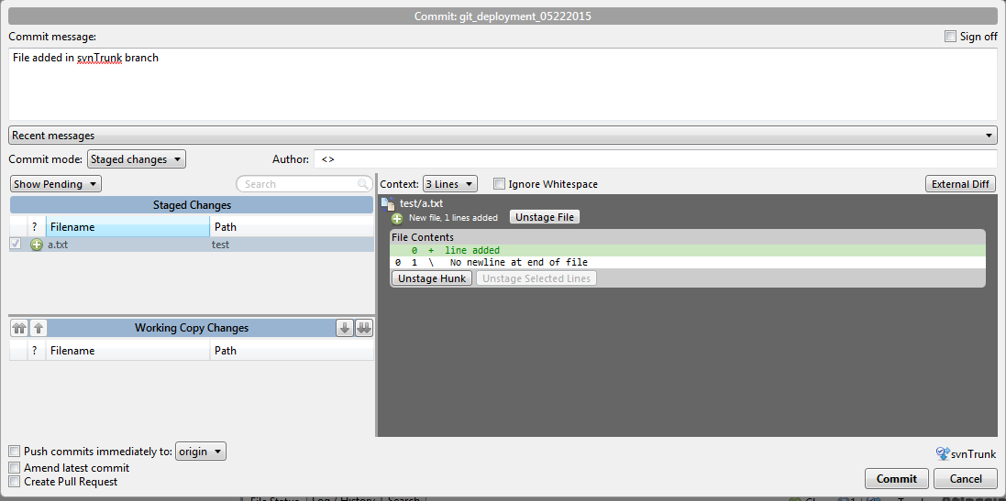

# **Reverse Commit**

Reverse commit option will revert back the changes that are committed. For an example if a new file is added and committed, it can be reverted by selecting the reverse commit option which will also delete the file from the local repository.

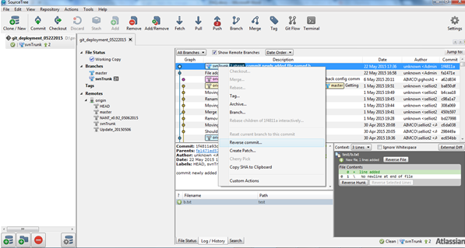

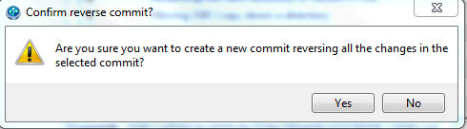

# **Merge**

Merging a branch is straight forward. Need to check out the branch we want to merge into. Right click on the branch and select the option ***merge #branchname into current branch***.

Merges are the easiest way to move changes between branches because they avoid breaking the commit history chain.

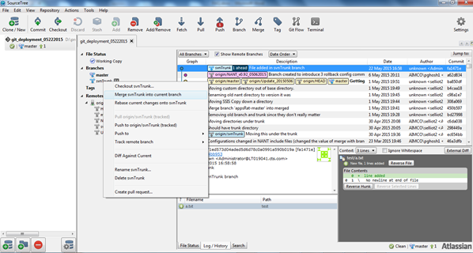

# **Push**

Push in source tree is sending the committed code from local repository to remote directory.

Right click the branch or select the Push option from the top menu to push the changes to the remote.

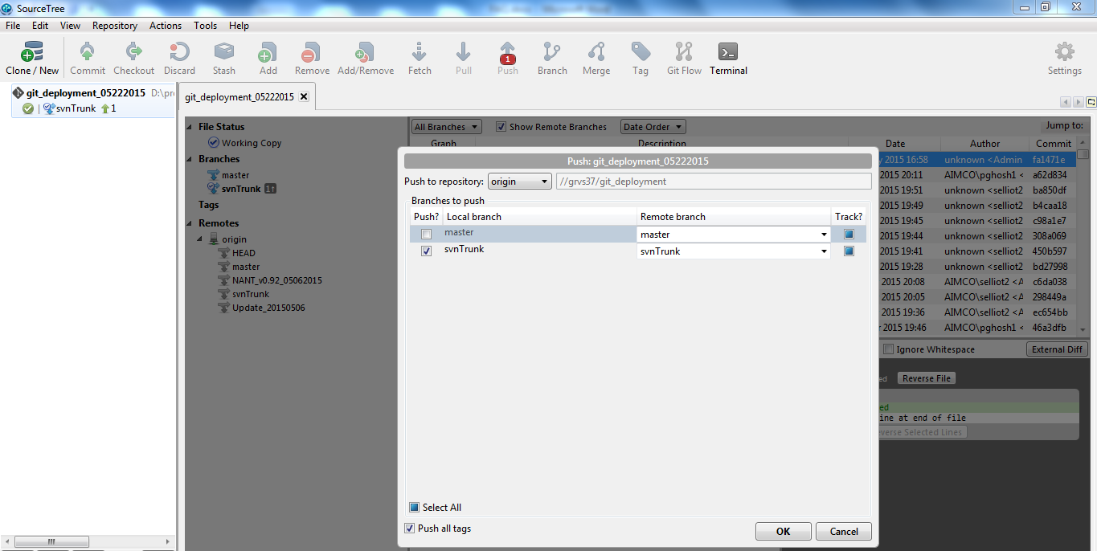

# **Fetch**

To fetch in source tree is downloading the newest changes from a remote server to the local repository, but keeping the repo as is without changing any files in the local directory.

# **Pull**

Pull in source tree is downloading the newest changes from a remote server to the local repository and checking out the newest code from the repo.

# **Stash**

When you stash changes, the items that will be stashed are the changes to tracked files in your working copy and in the staging area. Those changes will be saved in the stash, and reverted in the working copy and index.

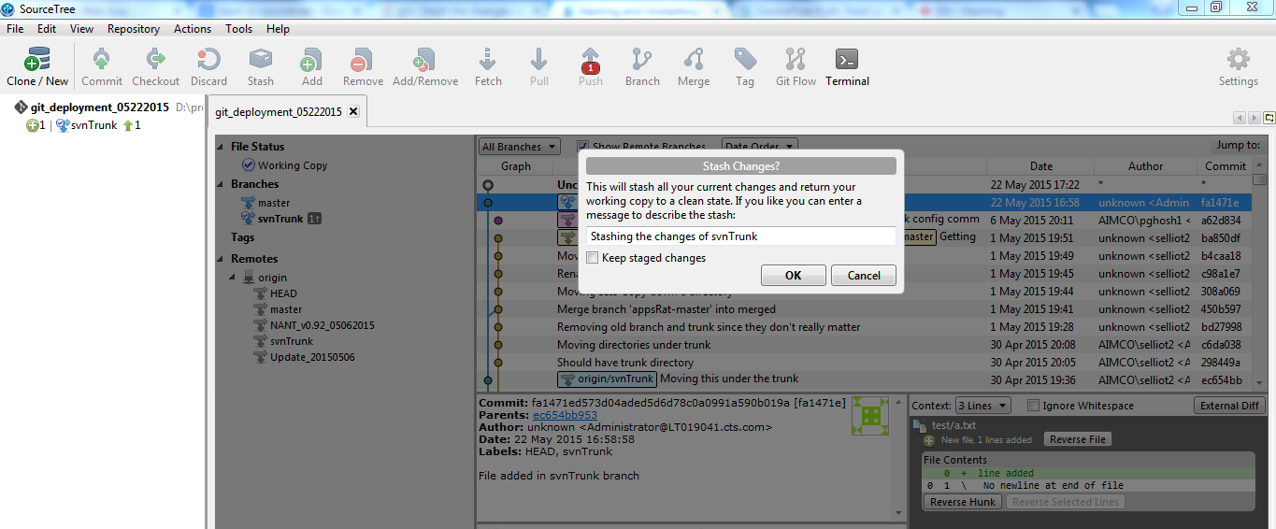

To bring the files again in the staged changes right click in the stash as shown below. This will bring the file in the stage changes section again.

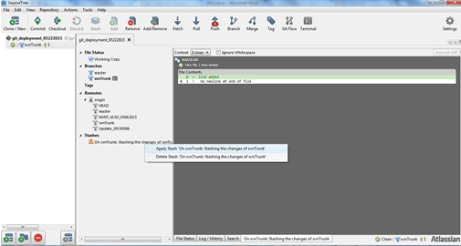

**FAQ:**

1. What is source tree?

Source tree is client of Git. It is like tortoise-svn.

1. Which version of source tree version is used?

Source Tree version 1.5.2.0

1. Difference between head and master?

Head is a pointer which basically points to origin\master whereas master is head branch (comparing to svn it can be treated as trunk). It can be assumed that origin\master will be having all the codes (all the code of branches will be merged to master)

1. Without accessing the code directly from the local drive how to check what the state of the files of individual branch is?

Checkout the branch under the branches section of the source tree; select the path from the left pane; right click on the path and select show in explorer to check the exact state of the files of that particular branch.

1. What is the best practice to commit the files or changes in a particular branch?

Checkout the branch and do the changes. These changes can be done by opening the appropriate editor (e.g.: visual studio, notepad++, etc.) and after doing the changes open the source tree and traverse to file status where the changed files will be seen. Stage those files and commit the files in that particular branch.

1. What is the difference between stage file and stage hunk?

Stage file means staging the entire file which include all the changes in the file whereas stage hunk means staging a portion of the file. Staging the entire hunk is same as staging a file.

1. How to track the branches?

A branch created in the remote server will not come in the local repository while cloning the repository in local drive.

To create a branch in the local repository checkout the branch of the remote server visible under the Remote section of the source tree.

1. What is the difference between unstage file and unstage hunk?

Unstage file means unstaging the entire file from the stage state which include all the changes in the file whereas unstage hunk means unstaging a portion of the file. Unstaging the entire hunk is same as unstaging a file.

1. Can a new branch be tracked if it is created in the local repository?

A new branch created in the local repository cannot be tracked with the branch of the origin as that branch is not present in the remote.

1. What is staging?

Changes done in any file needs to be staged before committing to the branch. Files can also be staged during the time of committing the files.

Stage is also known as Index.